Student Full Name : Kai Goh
Admin No : 231129U
Tutorial Group : IT2163-02

I have chosen the following security features for my assignment:

1. Account Registration Page
2. Data encryption and archival

Statement on Plagiarism
I certify that this assignment/report is my own work, based on my personal study and/or research and that I have acknowledged all material and sources used in its preparation, whether they be books, articles, reports, lecture notes, and any other kind of document, electronic or personal communication.

I also certify that this assignment/report has not previously been submitted for assessment in
any other unit, and that I have not copied in part or whole or otherwise plagiarised the work of other students and/or persons.

Signature | 
Date | 8 January 2026

1. Account Registration Page
With the purpose of creating new user accounts and storing sensitive user credentials. The account registration page is a critical component of a web application. However this component could be exploited by attackers to inject malicious code, compromise weak accounts or abuse the web application with automated registrations if not adequately secured.

Assumptions
The following assumptions are made for this web application:
- The application is developed using ASP.NET Core with Razor Pages
- User data is stored in a relational database
- ASP.NET Identity is used for authentication and authorisation
- Server-side validation is enabled
- The registration process collects common fields such as username, email address and password

1.1 Security Issue 1: Input Validation Vulnerabilities
Input validation vulnerabilities occur when a web application fails to properly validate or sanitise user-supplied input during registration. Attackers may exploit this weakness to submit malicious input such as SQL injection payloads or Javascript code. According to OWASP Top 10 (A03: Injection) and OWASP A07: Cross-Site Scripting (XSS), improper input handling can allow attackers to manipulate database queries or inject malicious scripts that execute in other users’ browsers.
If registration inputs such as usernames or email fields are not validated, attackers could:
- Inject SQL commands to manipulate the database (SQL Injection)
- Inject malicious scripts that execute when data is displayed
- Store malformed data that causes application errors

1.1 Mitigation Techniques
The primary mitigation technique technique is strict server-side input validation and sanitisation. This ensures that all data submitted during registration is checked to be in the expected format and processed before being stored in the database. This ensures that potential harmful characters won't be stored or executed in the database.

1.1 Explanation and Implementation
In ASP.NET Core, input validation can be enforced using data annotations on model properties. Validation rules ensure that only properly formatted input is accepted before data is processed or stored.

1.1 Key implementation steps:
- Define validation rules using attributes such as [Required], [StringLength] and [RegularExpression]
- Perform validation on the server side regardless of client-side checks
- Reject requests that fail validation and display appropriate error messages
- Use Razor’s built-in HTML encoding when displaying user input to prevent XSS

1.1 Example Code Snippet
Razor Pages automatically validate these rules before processing the registration request. Additionally, Razor automatically HTML-encodes output by default
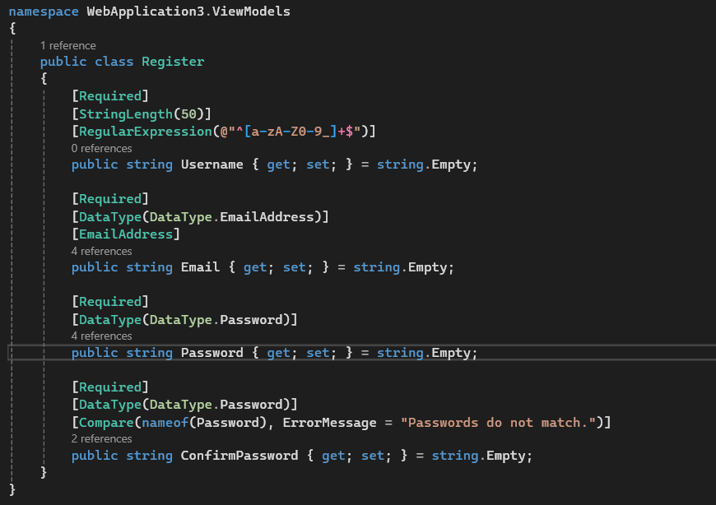
Furthermore, using @Model such as @Model.Username prevents injected scripts from being executed. As it will output the property “Username” with HTML encoding applied.

1.1 Why This Solution Works
- Server-side validation cannot be bypassed by disabling JavaScript
- Input constraints reduce the attack surface for injection attacks
- Automatic output encoding prevents stored and reflected XSS
- This approach aligns with OWASP-recommended secure coding practices

1.2 Security Issue 2: Weak Password Creation
Weak passwords are a common security issue during account registration. Users may choose short or simple passwords that are easily guessable or vulnerable to brute-force and credential-stuffing attacks. OWASP A07: Identification and Authentication Failures highlights weak password policies as a major cause of account compromise.
Examples of weak passwords include:
- Short passwords
- Dictionary words
- Passwords without complexity requirements

1.2 Mitigation Techniques
The mitigation technique is to enforce a strong password policy during registration. Where users' passwords are only stored after adhering to the password policy.

1.2 Explanation and Implementation
ASP.NET Identity provides built-in password policy enforcement. The application can be configured to require:
- A minimum password length
- Uppercase and lowercase characters
- Numbers and special characters
This is configured in the application startup settings.
A blacklist can also be set up where common dictionary words are not allowed to be used for passwords.

1.2 Example Code Snippet
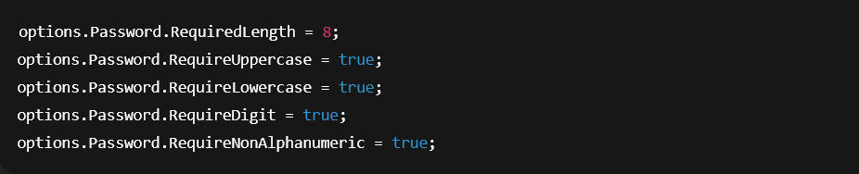If the password does not meet the policy requirements, registration is rejected and the user is prompted to choose a stronger password.
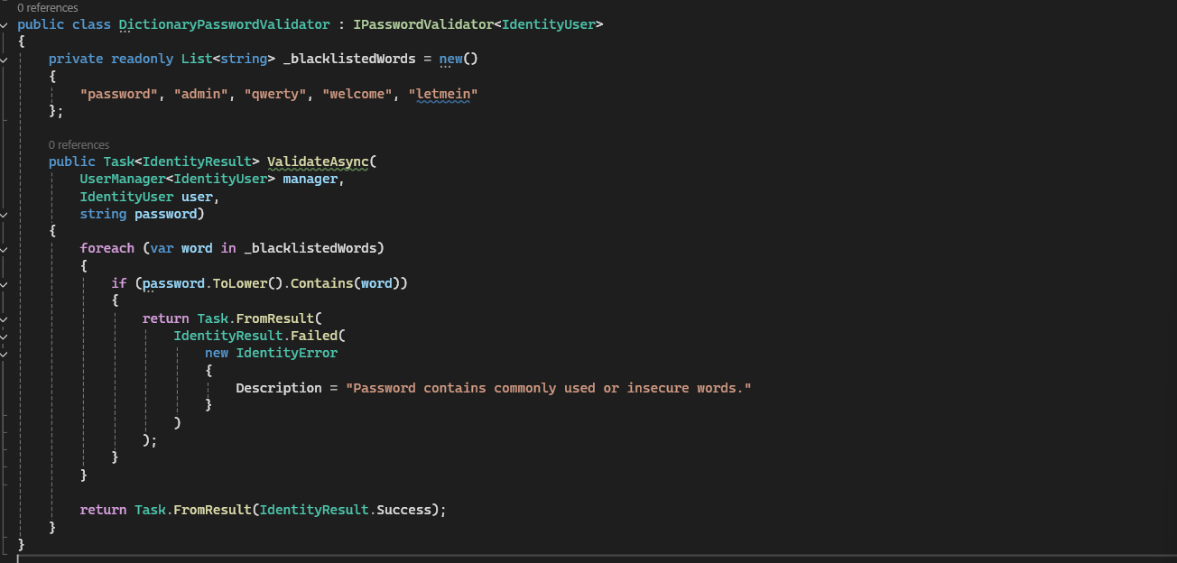
If the password contains dictionary words that are easily guessed. The user is prompted to change their password.

1.2 Why This Solution Works
- Increases resistance to brute-force and guessing attacks
- Reduces the success rate of credential-stuffing attacks
- Leverages framework-level security rather than custom logic
- Follows OWASP authentication best practices

1.3 Security Issue 3: Fake or Automated Account Creation
Without proper verification mechanisms, attackers may create fake or automated accounts using scripts or bots. These fake accounts can be used for spam, fraud, or denial-of-service attacks.
OWASP identifies automated abuse and insufficient verification as common weaknesses in authentication systems.

1.3 Mitigation Techniques
The recommended mitigation is email verification during account registration. This prevents the use of fake, mistyped, or unauthorized email addresses being used.

1.3 Explanation and Implementation
After a user registers:
- The system generates a unique verification token
- A verification email containing a one-time link is sent to the user
- The account remains inactive until the email link is clicked
- Only verified accounts are allowed to log in
ASP.NET Identity provides built-in support for email confirmation workflows.

1.3 Example Code Snippet
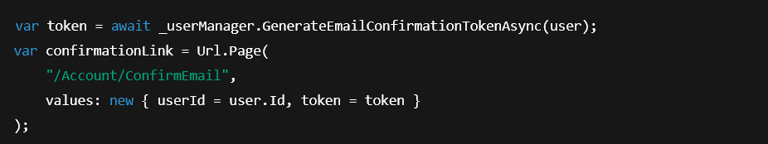

1.3 Why This Solution Works
- Prevents creation of fake or disposable accounts
- Ensures the user owns the registered email address
- Reduces automated abuse
- Improves overall account integrity

2. Data encryption and archival

Data encryption and archival are essential security components in a web application to protect sensitive information both during active use and when data is stored for long-term retention. If sensitive data is stored or archived without adequate protection, attackers may gain access to confidential information through database breaches, stolen backups, or insider threats.

Assumptions
The following assumptions are made for this web application:
- The application uses ASP.NET Core with a relational database
- User authentication is handled using ASP.NET Identity
- Sensitive data such as passwords and personal information is stored in the database
- Regular database backups are performed for recovery and compliance purposes
- Access to archived data is restricted to authorized personnel only

2.1 Security Issue 1: Insecure Storage of User Passwords
Storing user passwords in plaintext or using weak cryptographic techniques poses a serious security risk. If an attacker gains access to the database, plaintext or poorly protected passwords can be immediately compromised, leading to account takeovers and credential reuse attacks across other platforms.
According to OWASP A02: Cryptographic Failures and OWASP A07: Identification and Authentication Failures, improper handling of credentials is a major cause of data breaches.

2.1 Mitigation Techniques
The recommended mitigation is password hashing with a unique salt for each user account. Hashing will convert plaintext into cipher text and salting ensures that when the same passwords are hashed different cipher texts are generated.

2.1 Explanation and Implementation
In ASP.NET Core, password hashing is handled automatically by ASP.NET Identity, which uses strong cryptographic hashing algorithms such as PBKDF2.

2.1 Key implementation steps:
- User passwords are never stored in plaintext
- A unique salt is generated for each password
- The password and salt are hashed together
- Only the resulting hash is stored in the database
- During login, the entered password is hashed and compared against the stored hash

2.1 Example Code Snippet
ASP.NET Identity automatically applies hashing and salting without requiring custom cryptographic code.

2.1 Why This Solution Works
- Hashing is a one-way process and cannot be reversed
- Unique salts prevent rainbow table attacks
- Compromised password hashes cannot be easily reused
- Framework-managed hashing reduces implementation errors
- Aligns with OWASP and industry best practices

2.2 Security Issue 2: Unencrypted Sensitive Data stored in Database
Sensitive information stored in the database, such as personal details or confidential records, may be exposed if the database is compromised or accessed by unauthorized parties. Storing sensitive data in plaintext increases the impact of data breaches.
OWASP A02: Cryptographic Failures highlights the risks of failing to properly encrypt sensitive data at rest.

2.2 Mitigation Techniques
The mitigation technique is encryption of sensitive data at rest. Which is used to protect stored data from unauthorized access, even if the storage system is compromised.

2.2 Explanation and Implementation
Encryption at rest ensures that even if attackers gain access to the database or backup files, the stored data remains unreadable without the encryption keys.

2.2 Key implementation steps:
- Identify sensitive fields that require encryption
- Encrypt data using strong symmetric encryption (e.g. AES)
- Store encryption keys securely outside the source code
- Decrypt data only when required by authorized processes
In ASP.NET Core, encryption services can be implemented using the built-in Data Protection API.

2.2 Example Code Snippet

2.2 Why This Solution Works
- Encrypted data remains protected even if storage is compromised
- Strong encryption algorithms are resistant to brute-force attacks
- Secure key management reduces the risk of key exposure
- Limits the impact of insider threats
- Complies with data protection best practices

2.3 Security Issue 3: Unsecure Data Archival and Backup Storage
Archived data and database backups often contain highly sensitive information such as user credentials, personal details, and historical transaction records. These archives are frequently overlooked during security design and may be stored without encryption or proper access controls.
Attackers may specifically target backup files because:
- Backups are often stored outside the main production environment
- Security controls on backups may be weaker than live systems
- Archived data may be retained longer than necessary
According to OWASP A02: Cryptographic Failures, failure to protect stored data and backups can result in severe data breaches even if the main application is well secured.

2.3 Mitigation Techniques
The recommended mitigation is secure data archival and encrypted backups with access control. Which protects sensitive and historical data from loss, unauthorized access, and misuse, while ensuring availability for recovery and compliance purposes.

2.3 Explanation and Implementation
The secure archival process in a typical ASP.NET / ASP.NET Core web application can be implemented through the following steps:

Step 1: Encrypt Data Before Archival
Before database backups or archival files are stored, the data should be encrypted using a strong symmetric encryption algorithm such as AES (Advanced Encryption Standard).
- Encryption should be applied to the backup file itself, not only to individual database fields
- This ensures that archived files remain unreadable if accessed without authorization
- When a scheduled backup is generated, the backup file is encrypted using an encryption service
- The encrypted backup is then stored in the archival location

Step 2: Secure Encryption Key Management
Encryption keys must be stored and managed securely to prevent unauthorized access.
Key management practices include:
- Storing encryption keys outside the application source code
- Using secure configuration stores or key vault services
- Rotating encryption keys periodically
This prevents attackers from accessing both the encrypted data and the encryption keys at the same time.

Step 3: Restrict Access to Archived Data
Access to archival storage should be controlled using role-based access control (RBAC).
Implementation measures:
- Only authorized administrators are allowed to access backup files
- Read and restore permissions are granted based on job role
- Archived data is not accessible through the public-facing application
All access attempts to archival storage should be logged for auditing purposes.

Step 4: Enforce Data Retention and Deletion Policies
Archived data should not be retained indefinitely.
Implementation steps:
- Define retention periods based on business or compliance requirements
- Automatically delete outdated or unnecessary backup files
- Ensure deleted archives cannot be recovered without authorization
This minimizes the amount of sensitive data exposed if archival systems are compromised.

Step 5: Audit Logging and Monitoring
All archival-related activities should be logged and monitored.
Examples include:
- Backup creation events
- Access to archival storage
- Restore operations
Audit logs allow administrators to detect suspicious behavior and investigate security incidents.

2.3 Why This Solution Works
- Encryption ensures archived data remains protected even if storage is breached
- Secure key management prevents attackers from decrypting stolen backups
- Access control limits exposure to authorized personnel only
- Retention policies reduce long-term data exposure
- Audit logging provides accountability and supports incident response
Together, these measures provide defense-in-depth for data archival security and significantly reduce the risk of sensitive data leakage.

3. References

- OWASP Top 10 – https://owasp.org/www-project-top-ten/
- OWASP A02: Cryptographic Failures – https://owasp.org/Top10/A02_2021-Cryptographic_Failures/
- OWASP A03: Injection – https://owasp.org/Top10/A03_2021-Injection/
- OWASP A07: Identification and Authentication Failures – https://owasp.org/Top10/A07_2021-Identification_and_Authentication_Failures/
- OWASP Cross-Site Scripting (XSS) – https://owasp.org/www-community/attacks/xss/
- OWASP Input Validation Cheat Sheet – https://cheatsheetseries.owasp.org/cheatsheets/Input_Validation_Cheat_Sheet.html
- OWASP Authentication Cheat Sheet – https://cheatsheetseries.owasp.org/cheatsheets/Authentication_Cheat_Sheet.html
- OWASP Password Storage Cheat Sheet – https://cheatsheetseries.owasp.org/cheatsheets/Password_Storage_Cheat_Sheet.html

